**Name: Maaz Habib**

**Semester: 3rd Semester**

**REG #.20pwcse1952**

**Lab Report#04**

**DLD Lab**

**Department of Computer System Engineering**



**Submitted to:**

**Sir Faiz Ullah**

**Digital Logic & Computer Design Lab**

**TITLE:** **The UNIVERSAL GATES**

**AIM:**

* To study the realization of basic gates using universal gates (NAND & NOR).

**APPARATUS:**

* Power Supply, Breadboard.

**COMPONENTS:**

* ICs 7400 (quad 2-input NAND gate), LED.

**Circuit diagram of NAND:**

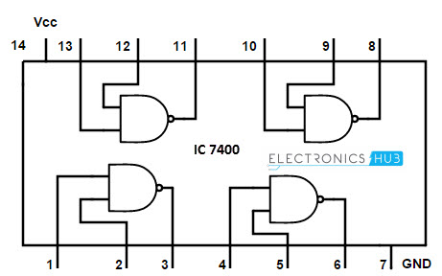

**Implementing EX-OR Using only NAND Gates:**

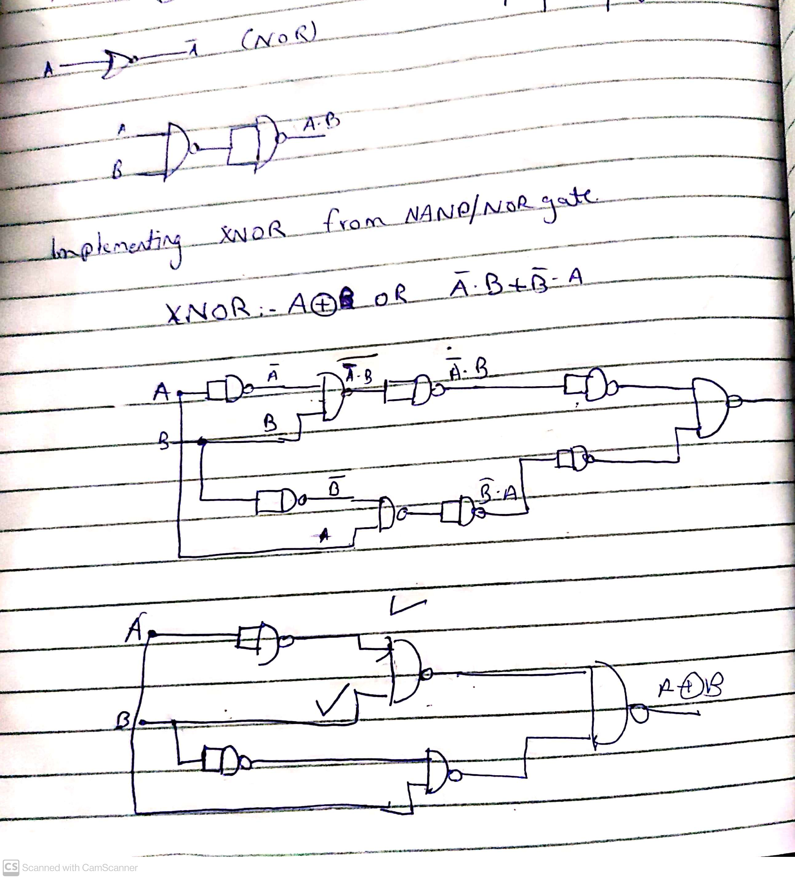

**Truth Table:**

|  |  |  |  |  |  |  |  |
| --- | --- | --- | --- | --- | --- | --- | --- |
| **A** | **B** | **A’** | **B’** | **A’.B** | **B’.A** | **A’.B + B’.A** | **A Ex OR B** |
| **0** | **0** | **1** | **1** | **0** | **0** | **0** | **0** |
| **0** | **1** | **1** | **0** | **1** | **0** | **1** | **1** |
| **1** | **0** | **0** | **1** | **0** | **1** | **1** | **1** |
| **1** | **1** | **0** | **0** | **0** | **0** | **0** | **0** |

**THE END**